Finger Lakes Tourism Alliance Marketing Report – 3rd Quarter 2020

AAA Program
- Follow up with agents requesting a webinar took place in the 3rd quarter. All requested preferred to view the recorded PowerPoint presentation slated to take place in 2020 rather than host a live webinar.
RESULTS
  - Follow up will be conducted in 2020 to offer all AAA / CAA offices the opportunity to view and keep the voice recorded PowerPoint for training throughout the year.

Collateral Materials
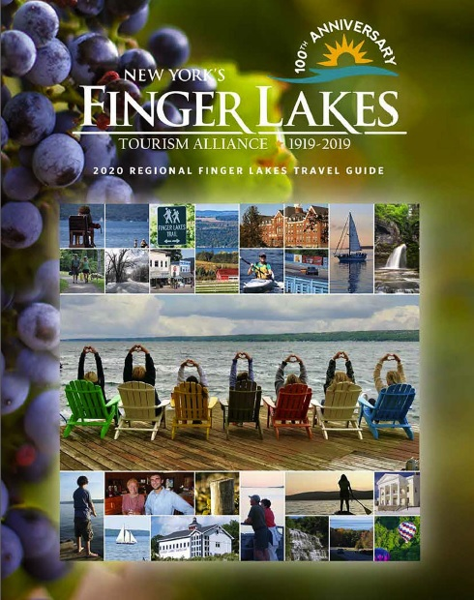
- FLTA’s Travel Guide distribution numbers for the 3rd quarter:
  - July = public requests and 4,766 bulk/partner distributions
  - August = 568 public requests and 6,704 bulk/partner distributions
  - September = 973 public requests and 4,165 bulk/partner distributions
  - A digital flipbook version of the Travel Guide was also posted online at Issuu.com for free. This version was accessed/read by 4,271 people in the 3rd quarter.
RESULTS
    - Year to date through the 3rd quarter total distributions = 96,696 which represents a 9% decrease year to date in requests over year to date in 2018.
    - Views of the online flipbook version of the Travel Guide are at 6,433 year to date through the third quarter representing a 6% increase over 2018.
    - With flipbook views and travel guide deliveries the Finger Lakes travel guide has been viewed by 103,129 individuals year to date in 2019, a 2% decrease year to date over 2018. As expected the digital trend has swapped out the interest in the print, but there is always a need for print in the pre-planning process.

Consumer Shows
- Anderson’s Brochure has not been able to attend shows due to the COVID-19 outbreak.

Cooperative Marketing
- The Group Travel Planner was sold and design and development took place in the 3rd quarter, primarily in August with files being delivered to the printer in O.
RESULTS
  - The 2020 Marketing Plan was approved by the FLTA Board of Directors in July and the 2020 Partner Opportunities Catalog was created and approved by the Board and Marketing Committee.
  - Sales efforts and billing for 2020 began August 1st and continued through the remainder of the 3rd quarter and into the 4th quarter.

FingerLakes.org
 | Unique Page views | Number of Visits – Not measured by Goggle Anymore | Pages Viewed | Avg. Time on Site
July‘19 | 156,064 |  | 214,609 | 1:34
August ‘19 | 138,664 |  | 190,702 | 1:30
Sept ‘19 | 99,490 |  | 138,806 | 1:31
3rd Quarter ‘19 | 394,218 |  | 544,117 | 1:31

 | Unique Page views | Number of Visits – Not measured by Goggle anymore | Pages Viewed | Avg. Time on Site
July‘18 | 155,312 |  | 293,575 | 2:40
August ‘18 | 130,799 |  | 182,051 | 2:43
Sept ‘18 | 95,629 |  | 132,642 | 2:35
3rd Quarter ‘18 | 381,740 |  | 608,268 | 2:39
 | Unique Visitors | Number of Visits | Pages Viewed | Avg. Time on Site
July‘18 | 58,908 | 72,754 | 293,575 | 2:40
August ‘18 | 49,270 | 60,575 | 182,051 | 2:43
Sept ‘18 | 36,624 | 45,245 | 132,642 | 2:35
3rd Quarter ‘18 | 144,802 | 178,574 | 608,268 | 2:39

Book Direct
 | Searches  Conducted | Website Referrals
July ‘19 | 6,987 | 5,755
August ‘19 | 5,747 | 4,355
September ‘19 | 3,890 | 3,213
3RD Quarter ‘19 | 16,624 | 13,323

 | Searches  Conducted | Website Referrals
July ‘18 | 3,728 | 3,046
August ‘18 | 3,510 | 3,010
September ‘18 | 2,266 | 1,716
3RD Quarter ‘18 | 9,504 | 7,772

RESULTS
- Year to date through Q3 in 2019 BookDirect has resulted in 38,095 searches for Finger Lakes accommodations resulting in a 64% increase from the same time period in 2018. FLTA believes this to be on account of working with Corporate Communications on a search and SEO program to increase visibility, ensure that users are quality and not just quantity hitting the site but staying engaged with content. This is an ongoing program.

Email Marketing
- FLTA’s email campaigns include three different major types of communication:
  - Partner Newsletter sent out to a database of over 850 partner email addresses
  - Public Newsletter sent out to several different email addresses segmented lists for a total of 47,474 opted in email subscribers.
  - Exclusive Newsletters sent out to a database of over 56,000 opted in email subscribers, though the total database of newsletter subscribers hits over 60,000 individuals.

FLTA Partner Newsletter (Monthly)
 | Recipients | Bounce Rate | Open Rate | Click Rate
July Partner Newsletter | 821 | .4% | 28% | 4.8%
August Partner Newsletter | 822 | .2% | 28.9% | 1.8%
September Partner Newsletter | 829 | .2% | 34% | 2%
3rd Q Average | 824 | .27% | 30% | 10.6%
- Other correspondence sent included:
  - Survey completion request for Group Travel Planner insert inclusion for partner businesses who weren’t included in the prior edition.
  - Partnership renewal information, website advertising opportunities and open enrollment additional partner newsletter.
  - Finger Lakes Opportunity For Tourism Growth Seminars

FLTA Public Newsletter (Sent Bi-Monthly, 6 Sent Total)
July – August 2019
Subject Line: “Music, Cherries, Garlic, Cheese, Pirates & More …. Festival Time in the Finger Lakes!”
 | Recipients | Bounce Rate | Open Rate | Click Rate
General Interest | 39,581 | 5% | 19% | 4%

 | Recipients | Bounce Rate | Open Rate | Click Rate
NYS Fair Contacts | 358 | .6% | 13% | 3%

 | Recipients | Bounce Rate | Open Rate | Click Rate
ABA Contacts | 103 | 2% | 17% | 1%

 | Recipients | Bounce Rate | Open Rate | Click Rate
PBA Contacts | 188 | 4% | 12% | 2%

 | Recipients | Bounce Rate | Open Rate | Click Rate
Heartland Contacts | 152 | 2% | 17% | 1%

 | Recipients | Bounce Rate | Open Rate | Click Rate
Winemaker for a Week Contacts | 1,360 | .1% | 19% | 5%

 | Recipients | Bounce Rate | Open Rate | Click Rate
Vacation Fun Leads | 5,002 | .6% | 9% | 2%

 | Recipients | Bounce Rate | Open Rate | Click Rate
International Travel Leads/Receptives | 336 | 2% | 13% | 0%

 | Recipients | Bounce Rate | Open Rate | Click Rate
Consumer Show Contacts | 1,865 | .6% | 7% | 2%

 | Recipients | Bounce Rate | Open Rate | Click Rate
Oprah Magazine Leads | 582 | 1% | 10% | 2%

 | Recipients | Bounce Rate | Open Rate | Click Rate
Tipping Point Communications Leads | 1,538 | .3% | 10% | 3%

 | Recipients | Bounce Rate | Open Rate | Click Rate
AAA/CAA Contacts | 1,295 | 3% | 16% | 2%

September - October 2019
Subject Line: “Apples, Foliage, Fire pits Welcome to Fall in the Finger Lakes!”
 | Recipients | Bounce Rate | Open Rate | Click Rate
General Interest | 44,809 | 4% | 16% | 2%

 | Recipients | Bounce Rate | Open Rate | Click Rate
NYS Fair Contacts | 348 | 1% | 9% | 1%

 | Recipients | Bounce Rate | Open Rate | Click Rate
ABA Contacts | 101 | 3% | 16% | 1%

 | Recipients | Bounce Rate | Open Rate | Click Rate
PBA Contacts | 183 | 4% | 14% | 1%

 | Recipients | Bounce Rate | Open Rate | Click Rate
Heartland Contacts | 152 | 4% | 23% | 1%

 | Recipients | Bounce Rate | Open Rate | Click Rate
Winemaker for a Week Contacts | 1,354 | 1% | 13% | 2%

 | Recipients | Bounce Rate | Open Rate | Click Rate
Vacation Fun Leads | 4,981 | 1% | 11% | 1%

 | Recipients | Bounce Rate | Open Rate | Click Rate
International Travel Leads/Receptive Operators | 335 | 5% | 14% | 0%

 | Recipients | Bounce Rate | Open Rate | Click Rate
Consumer Show Contacts | 1,853 | 1% | 16% | 1%

 | Recipients | Bounce Rate | Open Rate | Click Rate
Oprah Magazine Leads | 577 | 1% | 11% | 2%

 | Recipients | Bounce Rate | Open Rate | Click Rate
Tipping Point Communications Leads | 1,532 | 1% | 12% | 2%

 | Recipients | Bounce Rate | Open Rate | Click Rate
AAA/CAA Contacts | 1,274 | 2% | 8% | 1%

RESULTS:
- FLTA is hitting a steady average of 1% and open rates hovering around the 20% mark or higher. As reported by Constant Contact, Travel and Tourism email benchmarks rate at 16% open rates, 11% bounce rates and 8% click through rates. FLTA is far outpacing and exceeding these results in a positive trend.
- FLTA is looking into sending out monthly public newsletters to keep audiences more engaged and content relevant all through the year with links back to partner content on FingerLakes.org.

Public Relations
- In an effort to grow awareness about the area we worked with Wine Waters and Wonders to plan group tours for the 4th quarter.
- Met with Legislators at the federal and state level, holding 25 meetings in the 3rd quarter, and 2 more are scheduled for the 4th quarter.
- Submission of the three following grants:
  - Wine Waters and Wonders
  - Marketing Plan
  - Website update
- Jessica Robideau met one on one with partners to discuss programming opportunities for 2020 and educate them of FLTA efforts for their business throughout the 2019 year.
RESULTS:
- These public relations outreaches and connections with the local community help to keep community and partner businesses aware of what FLTA is up to and keep the business name top of mind in a busy business landscape.

Social Media
- Facebook
  - The Finger Lakes Tourism Alliance business page has 35,788 likes, a 7% increase from 2018
  - Contests and giveaways provided by partners have left wide impact on increasing organic likes to both FLTA and partner pages, social shares and engagement.
  - Tipping Point Communications invested in Facebook advertising to drive attention to partner content, increase page likes, and bolster FingerLakes.org site views.
RESULTS
  - Top posts from Q3 include:
    - We shared our deepest condolences to Diane Moore and the family and many friends after the passing of Tim Moore, with a reaching of 7,781 and 227 comments, reactions, or shares.
    - Now available announcement for the DVD of Owl Gorge Production, “A Walk through Watkins Glen: Water’s Sculpture in Stone.” with a reach of 7,678 and 370 comments, reactions, or shares.
    - The Seneca Lake’s Sea Monster Killed By Steamer’s Sidewheel article with a reach of 6,235 and 147 comments, reactions, or shares.

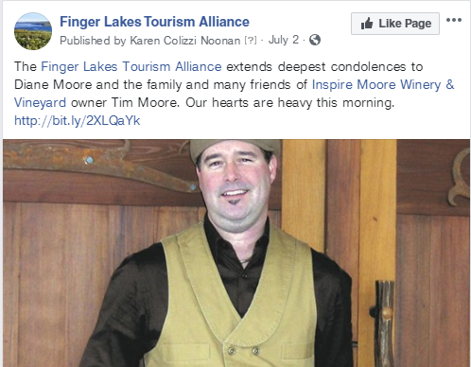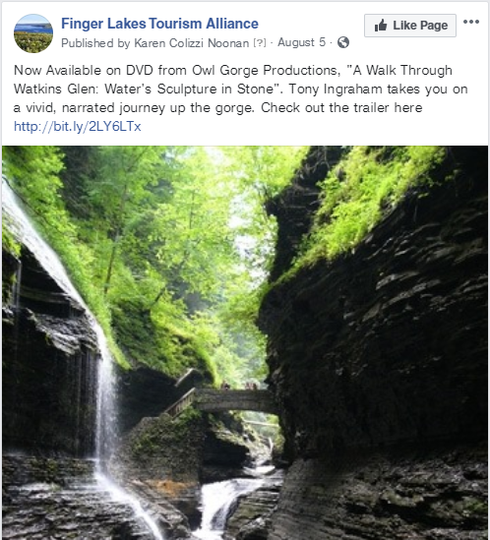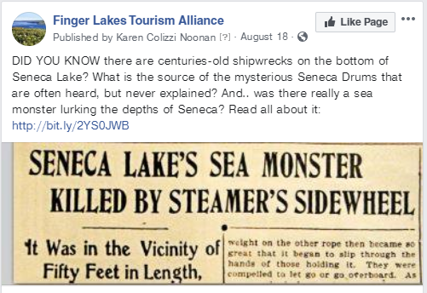
- Twitter
  - As of early July @TourFingerLakes has 7,958 followers.
- Instagram
  - The Instagram account for FLTA, @FingerLakesTourism has 3,154 followers as of early October.
- Pinterest
- The Pinterest account has 1,150 followers that are consistently accessing Finger Lakes Tourism Alliance partner materials and FingerLakes.org.

Trade Shows & Special Events
- None to report in the 3rd Quarter.

On The Horizon for 4th Quarter 2019
- Continuation and finalization of sales for 2020 travel guide and 2020 FLTA programs will take place.
- Preparation, layout, design and printing of the 2020 Finger Lakes Regional Travel Guide will take place.
- Participating in the FAM tours for a German group, Mary Moore Mason (Major UK Travel Writer), and UK travel Agent, Emma Miller.
- FLTA will coordinate regional meetings to upcoming 2020 group travel shows to allow industry connections, sharing of information, and to develop a cohesive message for the Finger Lakes region for those attending group travel shows in the first quarter of 2020.
- FLTA and FLOTG will continue to offer educational opportunities and seminars on important subject matter for businesses.
- Nominations for the Excellence in Customer Service Award will take place and the selection committee of previous year’s winners will select the 2019 winner.
- The FLTA Annual Holiday Party will take place Tuesday, December 10th at Lakeside Country Club.

Revised: 11/1/19
Prepared by Amanda Markessinis, Marketing & Sales Assistant

