Finger Lakes Tourism Alliance Marketing Report – 4th Quarter 2020

AAA Program
- All agents that reached out indicated that they preferred to view the recorded PowerPoint presentation slated to become available in 2021, rather than host a live webinar in the 4th quarter.
RESULTS
- Relationships continue with agents and offices through the public newsletter and interest in continued outreach and updates about the region is taking place from AAA club offices across the northeast.
- Follow-up will be conducted in 2021 to offer all AAA / CAA offices the opportunity to view and keep the voice recorded PowerPoint for training throughout the year.

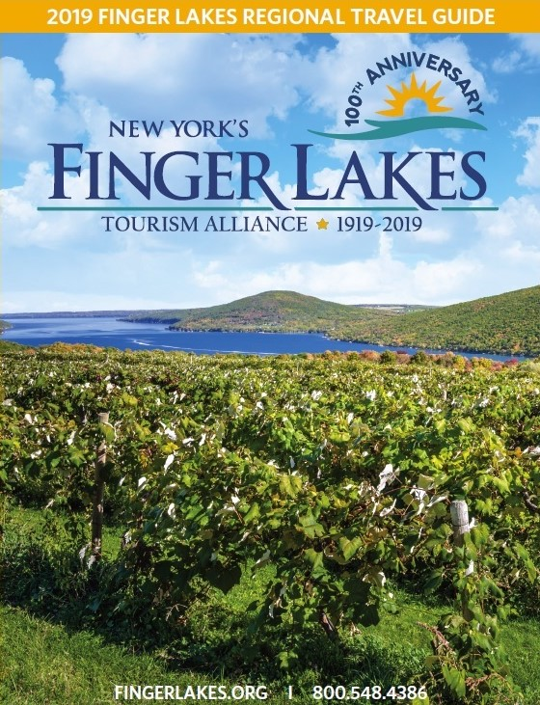
Collateral Materials
- FLTA’s Travel Guide distribution numbers for the 4th quarter:
  - October = 514 public requests and 3,234 bulk/partner distributions
  - November = 263 public requests and 4,278 bulk/partner distributions
  - December = 0 public requests and 73 bulk/partner distributions
  - A digital flipbook version of the Travel Guide was also posted online at Issuu.com for free. This version was accessed/read by 1,786 people in the 4th quarter.
RESULTS
  - Year to date through the 4th quarter total distributions = 96,473 which represents a 14% decrease year to date in requests over year to date through 2020. This is due to many visitor center locations no longer carrying paper and thus not allowing for guide distribution as well as a marketing committee and Board of Director approval to reduce the printed quantity of the guide produced from 125,000 copies in 2019 to 100,000 copies in 2020. COVID-19 also reduced travel due to quarantine restrictions and travel limitations.
  - Views of the online flipbook version of the Travel Guide are at 6,973 year to date through the 4th quarter, representing a 32% decrease over 2019. This is attributed to COVID-19 travel restrictions as noted with guide requests as well as significant decreases in group travel planning.
  - With flipbook views and travel guide deliveries the Finger Lakes travel guide has been viewed by 103,446 individual’s year to date in 2020.

Consumer Shows
- Anderson Brochure Distribution was contracted to participate in consumer shows for 2020. Due to COVID-19 they were not able to attend any shows for the 4th quarter of 2020 due to large group gathering restrictions and cancellations.

Cooperative Marketing
- The Group Travel Planner was slated to take place for production and layout. Due to significant changes and limitations in the group market and partner businesses not able to accept group business, an abbreviated version of the Group Travel Planner was posted as an online edition in the 4th quarter with advertisers appearing with ads that were placed.
RESULTS
- This publication had 14 impressions and this is as a result of very limited group travel activity taking place in 2020 with the pandemic.

FingerLakes.org
 | Pageviews | Unique Page Views | Entrances The number of times a visitor enters through a specific page | Pages Viewed | Avg. Time on Page
Oct ‘20 | 120,968 | 91,315 | 51,589 | 120,968 | 1:35
Nov ‘20 | 47,412 | 37,820 | 23,193 | 47,412 | 1:34
Dec ‘20 | 37,709 | 30,336 | 18,718 | 37,709 | 1:32
4th Quarter ‘20 | 206,089 | 159,471 | 93,500 | 206,089 | 1:33

 | Pageviews | Unique Page Views | Entrances  The number of times a visitor enters through a specific page | Pages Viewed | Avg. Time  On Page
Oct ‘19 | 119,541 | 87,027 | 48,722 | 119,541 | 1:28
Nov ‘19 | 59,348 | 45,804 | 28,059 | 59,348 | 1:27
Dec ‘19 | 62,469 | 47,569 | 29,836 | 62,469 | 1:30
4th Quarter ‘19 | 241,358 | 180,400 | 106,617 | 241,358 | 1:28

RESULTS
- Google has changed the metrics measured through Google Analytics over the year.
- Year to date in comparison to the year prior, FingerLakes.org has seen a 7% increase in time on page and a 1% increase in the number of entrances.
- Page viewed decreased based on SEO investment reduction due to budget constraints, partner investment and the COVID-19 pandemic.

Book Direct
 | Searches  Conducted | Website Referrals
October ‘20 | 4,303 | 3,598
November ‘20 | 1,241 | 736
December ‘20 | 867 | 611
^{4th} Quarter ‘20 | 6,411 | 4,945

 | Searches  Conducted | Website Referrals
October ‘19 | 2,783 | 2,130
November ‘19 | 1,254 | 842
December ‘19 | 1,259 | 763
^{4th} Quarter ‘19 | 5,296 | 3,735
RESULTS
- Compared to the Book Direct searches of the 4th Quarter in 2019, we’ve had a 21% increase in searches and a 43% increase in website referrals for the 2020 year.
- Year to date through Q4 in 2020 Book Direct has resulted in 54,422 searches for Finger Lakes accommodations, resulting in a 25% increase from the same time period in 2019.
- FLTA referred 44,947 FingerLakes.org visitors to FLTA accommodation partner websites through Book Direct. This is an 41% increase in referrals from 2019.
- These increases in views and visitation is correlated to a pent up demand for travel and future planning.

Email Marketing
- FLTA’s email campaigns include three different major types of communication:
  - Partner Newsletter sent out to a database of over 800 partner email addresses
  - Public Newsletter sent out to several different email addresses segmented lists for a total of opted in email subscribers.
  - Exclusive Newsletters sent out to a database of over 56,000 opted in email subscribers, though the total database of newsletter subscribers hits over 66,000 individuals.

FLTA Partner Newsletter (Monthly)
 | Recipients | Bounce Rate | Open Rate | Click Rate
October Partner Newsletter | 922 | .8% | 32% | 2%
November Partner Newsletter | 897 | .3% | 27% | 5%
December Partner Newsletter | 888 | .2% | 30% | 4%
4th Q Average | 902 | 4% | 30% | 4%
- Other correspondence sent included:
  - 2020 Partnership Satisfaction Survey
  - FLOTG Social media seminar and Business Challenges and Important Info for Businesses During COVID-19
  - 2021 Travel Guide Updates
  - Congressman Tom Reed’s outreach with private sector discussing business challenges and hearing concerns
  - Holiday wishes from FLTA and the FLTA virtual holiday party
  - Online edition of the Group Travel Planner call to action for content and partner input
Public Relations
- Jessica Robideau had a number of partner meetings both in person, like with Michael Hardy the newly appointed Director of the Watkins Glen Area Chamber of Commerce as well as with other partners virtually to catch up on industry happenings, touch base about FLTA planning and 2021 upcoming efforts, and collaborate about effective ways to work together for the remainder of 2020 and into 2021.
- Cindy Kimble also met with individuals looking to relocate to the Finger Lakes region to inform them about the area and opportunities available.
- Both Jessica and Cindy conducted 2021 planning meetings with partners to confirm programs and preferred placement for marketing opportunities and programming for 2021.
RESULTS:
- These public relations outreaches help to keep relevant with our partner businesses, inform them that FLTA is still working hard on their behalf.
- Our efforts also connect us with the local community, to keep travelers encourage to postpone not cancel travel plans and remember that the region will rebound and reopen.

Social Media
- Facebook
  - The Finger Lakes Tourism Alliance business page has 35,907 likes, an 1% increase from 4th Q of the year prior.

RESULTS
  - Top posts from Q4 include:
    - Winter and wine humor with links to FingerLakes.org for the Wineries page and leaf peeping information on the homepage.
    - The Windmill Farm & Craft Market was open for Black Friday this year and this promotion and announcement lead to a reach of 16,653 people, and 544 reactions, comments, and shares.
- Twitter
  - As of the end of December @TourFingerLakes has 7,731 followers.
  - Used to share news (press releases, events, upcoming weather, etc.) from partner businesses, and the Finger Lakes region.
  - In conversations with FLTA’s social media management company for 2021 it was noted that Twitter is aging out as a platform for engagement.
- Instagram
  - The Instagram account for FLTA, @FingerLakesTourism has 3,780 followers as of the end of December.
  - Created “highlights” on the account to feature event coverage, and other social media promotions.
- Pinterest
- The Pinterest account has 1,002 followers that are consistently accessing Finger Lakes Tourism Alliance partner materials and FingerLakes.org.

RESULTS
- Twitter: The FLTA had a 3% decrease in followers over end of year 2019.
  - We believe this is due to Twitter becoming less of a travel influencer and trip planning tool and more of a way to engage with visitors real time. This platform seems to be trending out.
- Instagram: Instagram audience grew 5% in 2020 over the same timeframe in 2019.
- Pinterest: Year to date the FLTA account had a 3% increase of followers.
  - We’ve increased the amount of content added to include the itineraries from around the region but this will be looking to update in 2020 with the onboarding of Local IQ to help facilitate social media posting.

Trade Shows & Special Events
- The FLTA hosted the 2020 holiday party via a virtual platform on Tuesday December 15th, from 3-4pm.
RESULTS
- There were over 50 partners in attendance.
- FLTA announced the 2020 Excellence in Customer Service award to the entire team at Plum Point Lodge on Seneca Lake and Sapalta Restaurant, the in house restaurant at Plum Point Lodge.
- FLTA announced the second Finger Lakes Region Scholarship recipient, Nikita Blackburn, at student at Tompkins Community College studying hospitality to help further her education and garner an employment position within the Finger Lakes region after completion of her studies.

On The Horizon for 1st Quarter 2020
- Continuation of efforts to designate the Finger Lakes region as a National Heritage Area.
- Preparation, layout, design, and printing of the 2021 Finger Lakes Regional Travel Guide will take place.
- Jessica is attending the Heartland Travel Showcase that’s taking place virtually February 9-10, 2021 to educate group leaders about events taking place in the Finger Lakes and plant the seed of group travel and adaptation for 2021 to promote planning for the future.
- FLTA and FLOTG will continue to offer educational opportunities and seminars on important subject matter for businesses.

Revised:
4/9/21
Prepared by Jessica Robideau Hathaway Marketing & Sales Director

